FieldSync
Database Schema Design
(ERD — Entity Relationship Diagram)
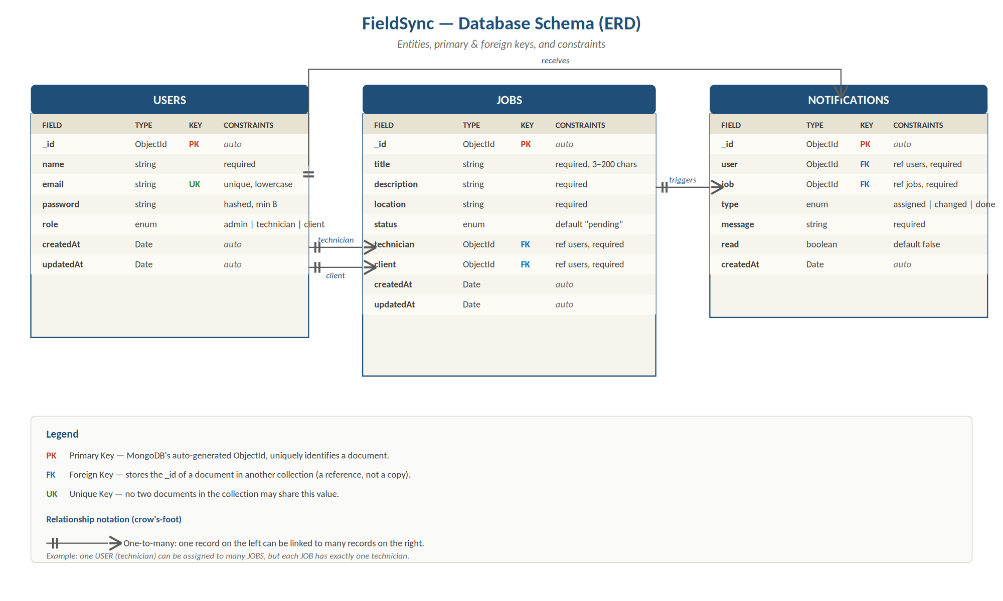
Figure 1. FieldSync entity relationship diagram

Overview
FieldSync uses MongoDB, a document database, but the schema design follows classic relational principles — tables (collections), primary keys, foreign keys, and clearly defined relationships. The ERD above is the single source of truth for what data the system stores and how the pieces connect.
There are three collections: USERS, JOBS, and NOTIFICATIONS. Every job links to two users (a technician and a client). Every notification links to the user receiving it and the job it relates to. That's the whole shape of the system.

Understanding the keys
Primary Key (PK). Every document in every collection has an _id field, automatically generated by MongoDB as a unique ObjectId. This is the document's permanent identifier — once assigned, it never changes, and no two documents in the same collection can share one. It's how we uniquely refer to any record in the system.
Foreign Key (FK). When a document needs to reference another document, it stores the other document's _id instead of copying the data. For example, a JOB stores its technician's _id rather than copying the technician's name and email. This keeps data consistent: if the technician changes their name, we update it in one place (the USERS collection) and every job that references them sees the update automatically.
Unique Key (UK). A field that must be unique across the collection, even though it's not the primary key. The email field on USERS is a unique key — two users can have the same name, but never the same email. This is enforced by the database itself, so duplicates can never sneak in regardless of what the application code does.

Entity 1: USERS
Stores every person who can log into FieldSync, regardless of role. Admins, technicians, and clients all live in this one collection — what distinguishes them is the value of the role field.

Fields
- _id (PK). Auto-generated ObjectId. The unique identifier used everywhere else when something needs to reference a user.
- name. The user's full name. Required. Used for display in dashboards and notifications.
- email (UK). Required, unique across the whole collection, stored in lowercase so different capitalisations don't create duplicate accounts. Used as the login identifier.
- password. Required. Stored as a bcrypt hash, never as plain text. Minimum 8 characters before hashing.
- role. An enum field that must be exactly one of three values: admin, technician, or client. This single field drives every permission check in the system.
- createdAt, updatedAt. Automatic timestamps managed by the database — they update without us having to set them explicitly.

Entity 2: JOBS
The core entity. Each document represents one maintenance task — the work to be done, where, by whom, and for which client. This collection is the one that grows fastest as the system is used.

Fields
- _id (PK). Auto-generated ObjectId.
- title. Short description of the task, between 3 and 200 characters. Shown in lists and notifications.
- description. The full description of the work required. Required.
- location. The address or site description. Required — without this, the technician can't get to the right place.
- status. An enum representing where the job is in its lifecycle. Allowed values: pending, in_progress, completed, verified. Every new job starts as "pending" by default.
- technician (FK → USERS). Stores the _id of the user assigned to do the work. Required. The application enforces that this reference must point to a user with role: technician.
- client (FK → USERS). Stores the _id of the user who requested the work. Required. The application enforces that this reference must point to a user with role: client.
- createdAt, updatedAt. Automatic timestamps.

Why two foreign keys to the same collection?
Both the technician and the client are USERS, but they play different roles in the relationship. This is completely normal — the JOBS collection treats them as separate references and the role field on each user determines what kind of user they are.

Entity 3: NOTIFICATIONS
Stores the automated messages sent to clients as their jobs progress. The PRD requires three trigger events: when a job is assigned, when its status changes, and when it's marked complete. Each of those creates one document in this collection.

Fields
- _id (PK). Auto-generated ObjectId.
- user (FK → USERS). The recipient. Stores the _id of the user this notification is for. Required.
- job (FK → JOBS). The job this notification is about. Required. Lets the client click the notification to jump straight to the relevant job.
- type. An enum identifying which event triggered the notification: assigned, status_changed, or completed. Useful for showing different icons or sorting notifications by category.
- message. The human-readable text shown to the user. Required.
- read. A boolean flag, false by default, that flips to true once the client has viewed the notification. Drives the unread count badge in the UI.
- createdAt. Automatic timestamp. Notifications are usually displayed newest-first using this field.

Relationships
All three relationships in this schema are one-to-many. The notation "||--o{" in the diagram (called crow's-foot notation) reads as: the side with the double bar (||) holds one record, and the side with the three-pronged "crow's foot" (o{) holds many.

USERS → JOBS (as technician)
One technician can be assigned to many jobs (a busy technician might have ten open jobs at once). But each job has exactly one assigned technician at a time. If the technician changes, the FK is updated — the job stays the same record.

USERS → JOBS (as client)
One client can have many jobs in the system over time. Each job is for exactly one client. Same shape as the technician relationship, just a different role.

USERS → NOTIFICATIONS
One user receives many notifications over the lifetime of their account. Each notification belongs to exactly one user — notifications are never shared.

JOBS → NOTIFICATIONS
One job generates multiple notifications across its lifecycle (one when it's assigned, more when status changes, one when it's completed). Each notification is about exactly one job.

Constraint summary
Constraints are rules the database (and application layer) enforce on every write. They prevent invalid data from ever being saved, regardless of bugs in higher layers.
- Required fields. Marked in the diagram. A document missing any required field is rejected at save time.
- Enum constraints. role, status, and type can only hold specific predefined values. Trying to save a job with status: "banana" is rejected immediately.
- Uniqueness. email on USERS must be globally unique within the collection.
- Length limits. title is capped at 3–200 characters to keep displays clean. Other free-text fields have generous upper bounds to prevent abuse.
- Defaults. status defaults to "pending", read defaults to false. These take effect when those fields aren't explicitly provided.
- Referential integrity. Foreign keys must point to documents that actually exist. While MongoDB itself doesn't enforce this automatically, the application layer does — we never store an _id that doesn't correspond to a real record.

Example: tracing one job through the schema
To make this concrete, here's what's saved when a single job moves through its lifecycle:
- 1. Setup. USERS already has Ama (admin), Kwame (technician), and Akua (client). Each has an _id.
- 2. Create. Ama creates a job: "Fix leaky tap." A new JOBS document is saved with status: pending, technician: Kwame's _id, client: Akua's _id.
- 3. Auto-notification. A NOTIFICATIONS document is created with user: Akua's _id, job: the job's _id, type: assigned, message: "Kwame has been assigned to your job 'Fix leaky tap'."
- 4. Status update. Kwame marks the job as in_progress. The JOB's status field is updated. A new NOTIFICATIONS document is created for Akua with type: status_changed.
- 5. Completion. Kwame marks the job as completed. The JOB updates, and another NOTIFICATIONS document is created with type: completed.
- 6. Verification. Ama reviews the completed work and updates the JOB to status: verified. The lifecycle ends. The job now has one document in JOBS and three documents in NOTIFICATIONS that reference it.

— End of Document —

